

EIFG 401(K) PSP & Trust

**February 3rd, 2025**

**Patricia Whitney**

**Phone: (407) 481-9449**

**February 6th, 2025**

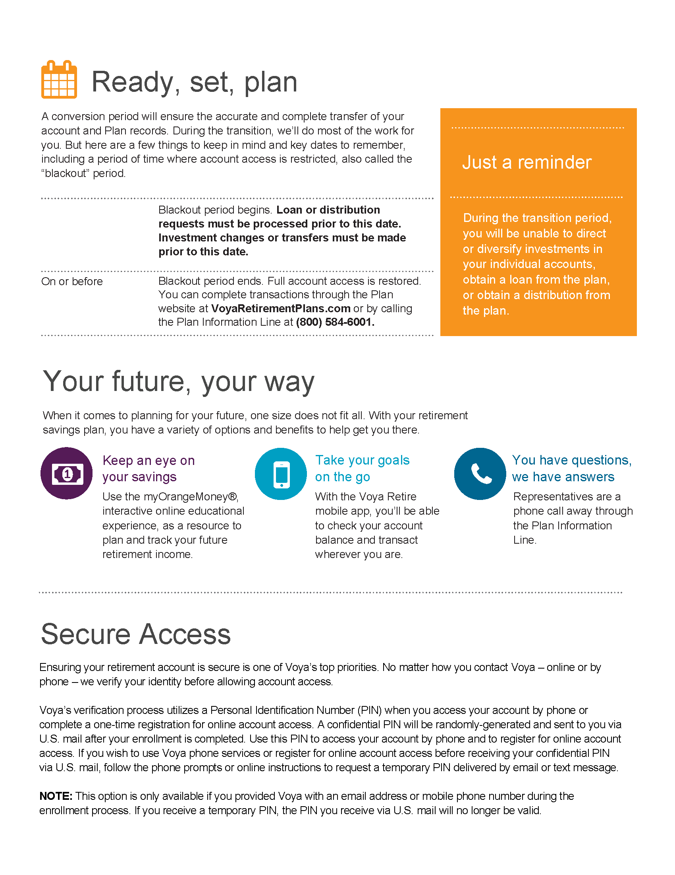

**February 6th, 2025**

**February 3rd, 2025**

